Observing Cells Practical Guide
Aim: To use a light microscope to observe, draw, and label biological specimens.
Equipment Per Group | Method | Notes and guidance
- Light Microscope (with bulb or mirror)  - Pre-prepared slides of plant and animal cells | - Select a prepared slide and place it on the microscope stage  - Select the lowest power objective lens (x4) by rotating the nose piece  - Use the coarse adjustment knob to raise the stage so the slide is nearly – but not quite – touching the lens  - Look through the eyepiece and use the coarse adjustment knob to lower the stage until the slide is brought into focus  - Use the fine adjustment knob to bring the cells into clear focus  - Select a higher power lens (x100 or x400) by rotating the nose piece  - Use the fine adjustment knob again to bring the cells into clear focus  - Make a labelled drawing of the cells you observe  - Include the total magnification with your drawing (objective magnification x eyepiece magnification) | Discuss which animal and plant cell slides you wish to use with the technician beforehand. Remember to give plenty of time before the practical in case new slides must be prepared or ordered.  If you have a USB microscope or any other way of displaying a microscope’s view on a screen, consider demonstrating the method to the class before the practical using this.  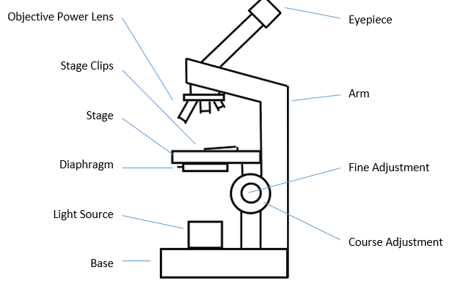
General Teacher Notes
A risk assessment must be completed for this practical. The risk assessment should be specific to the class concerned and written only by the teaching member of staff.

Broken glass should always be cleared immediately and disposed of in the broken glass bin.

You may wish to replace this diagram with one that more closely resembles the microscopes used in your school.

Clearing up
Return all used equipment to the trays and/or trolley in the condition in which it arrived. If there have been any breakages or if any microscopes were faulty, alert the technician.

Any broken glass slides must be cleared up immediately and placed in the laboratory sharps bin.

Technician Notes | Hazcards | Clearing away
Pre-prepared animal and plant cell slides can be purchased from most suppliers, but it is also possible to create your own if you have the resources.  Always check microscopes before giving them to students as there are many parts that can be broken or knocked out of calibration. | n/a | Return all pre-prepared slides to their boxes tidily. Return microscopes to the microscope trolley or as directed by the class teacher.

